Cobbler 自动化系统安装

简介
无需进行人工干预即可安装机器。cobbler集成了PXE、DHCP、DNS、Kickstart服务管理和yum仓库管理工具，相对之前的 Kickstart 更加快捷、方便的批量布署redhat、centos类系统 cobbler 客户端koan支持虚拟机安装和操作系统重装.
Cobbler 设置一个 PXE 引导环境（它还可使用 yaboot 支持 PowerPC），并控制与安装相关的所有方面，比如网络引导服务（DHCP 和 TFTP）与存储库镜像。当希望安装一台新机器时，Cobbler进行的工作包括：
使用一个以前定义的模板来配置 DHCP 服务（如果启用了管理 DHCP）
将一个存储库（yum 或 rsync）建立镜像或解压缩一个媒介，以注册一个新操作系统
在 DHCP 配置文件中为需要安装的机器创建一个条目，并使用您指定的参数（IP 和 MAC 地址）
在 TFTFP 服务目录下创建适当的 PXE 文件
重新启动 DHCP 服务以反映更改
重新启动机器以开始安装（如果电源管理已启用）
常用架构如下：
- 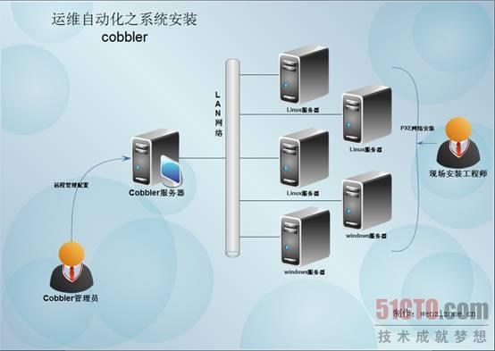
Cobbler支持命令行管理，web界面管理，还提供了API接口，可以方便二次开发使用。,cobbler web界面可以更好的方便用户操作

本次试验部署
cobbler服务器：10.90.5.133（centos6.4）
实验拓扑
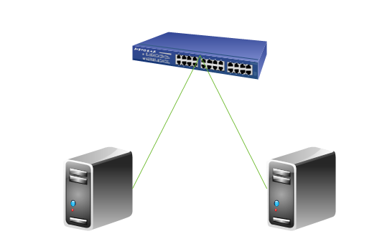
Cobbler server client
10.90.5.133
本次网络安装使用的系统版本安装包
CentOS-6.1-x86_64-bin-DVD1.iso CentOS-6.4-x86_64-bin-DVD1.iso
ubuntu-12.04.4-alternate-amd64.iso lubuntu-14.04-alternate-amd64.iso(无图形界面)

安装cobbler ,搭建cobbler环境

安装semanage命令的包 policycoreutils-python
# yum -y install policycoreutils-python

安装pykickstart
# yum -y install pykickstart

安装cobbler web相关服务
# yum install -y httpd
# yum install -y rsync tftp-server xinetd dhcp

安装第三方软件源rpmforce源
# wget http://packages.sw.be/rpmforge-release/rpmforge-release-0.5.2-2.el6.rf.x86_64.rpm
# rpm -ivh rpmforge-release-0.5.2-2.el6.rf.x86_64.rpm
或
# rpm -ivh http://dl.fedoraproject.org/pub/epel/6/x86_64/epel-release-6-8.noarch.rpm
# yum list
# yum upgrade

安装cobbler
# yum install -y cobbler

启动cobbler和httpd服务
# /etc/init.d/cobblerd start
# /etc/init.d/httpd start
若报错
Starting httpd: httpd: apr_sockaddr_info_get() failed for centos
httpd: Could not reliably determine the server's fully qualified domain name, using 127.0.0.1 for ServerName
解决办法：
# vim /etc/httpd/conf/httpd.conf
ServerName localhost:80
然后再重启http服务

检查cobbler配置
# cobbler check
The following are potential configuration items that you may want to fix:

1 : The 'server' field in /etc/cobbler/settings must be set to something other than localhost, or kickstarting features will not work. This should be a resolvable hostname or IP for the boot server as reachable by all machines that will use it.
2 : For PXE to be functional, the 'next_server' field in /etc/cobbler/settings must be set to something other than 127.0.0.1, and should match the IP of the boot server on the PXE network.
3 : some network boot-loaders are missing from /var/lib/cobbler/loaders, you may run 'cobbler get-loaders' to download them, or, if you only want to handle x86/x86_64 netbooting, you may ensure that you have installed a *recent* version of the syslinux package installed and can ignore this message entirely. Files in this directory, should you want to support all architectures, should include pxelinux.0, menu.c32, elilo.efi, and yaboot. The 'cobbler get-loaders' command is the easiest way to resolve these requirements.
4 : change 'disable' to 'no' in /etc/xinetd.d/rsync
5 : reposync is not installed, need for cobbler reposync, install/upgrade yum-utils?
6 : yumdownloader is not installed, needed for cobbler repo add with --rpm-list parameter, install/upgrade yum-utils?
7 : debmirror package is not installed, it will be required to manage debian deployments and repositories
8 : The default password used by the sample templates for newly installed machines (default_password_crypted in /etc/cobbler/settings) is still set to 'cobbler' and should be changed, try: "openssl passwd -1 -salt 'random-phrase-here' 'your-password-here'" to generate new one
9 : fencing tools were not found, and are required to use the (optional) power management features. install cman or fence-agents to use them

Restart cobblerd and then run 'cobbler sync' to apply changes.
这段信息大意就是：
1，编辑/etc/cobbler/settings文件，找到 server选项，修改为适当ip地址，本实例配置ip为：10.90.5.133
2，编辑/etc/cobbler/settings文件，找到 next_server选项，修改为适当ip地址，本实例配置ip为：10.90.5.133
3，执行 cobbler get-loaders，系统将自动下载loader程序，完成修复工作。
4, 编辑/etc/xinetd.d/rsync文件，将文件中的disable字段的配置由yes改为no
5, reposync没安装,安装yum-utils
6, yumdownloader没安装,安装yum-utils
7，提示说debmirror没安装。如果不是安装 debian之类的系统，此提示可以忽略
CentOS 6使用RHEL 5的包就可以。
8，修改cobbler用户的默认密码，可以使用如下命令生成密码，并使用生成后的密码替换/etc/cobbler/settings中的密码。生成密码命令：
openssl passwd -1 -salt 'random-phrase-here' 'your-password-here'
其中“random-phrase-here”为干扰码
9, fencing工具未安装，安装cman或者fence-agents
所有提示全部fix之后，执行
/etc/init.d/cobblerd restart

根据检查提示进行修改与操作
1/2, # vim /etc/cobbler/settings
server: 10.90.5.133
next_server: 10.90.5.133

3, # cobbler get-loaders --force

4, # vim /etc/xinetd.d/rsync
service rsync
{
disable = no
flags = IPv6
socket_type = stream
wait = no
user = root
server = /usr/bin/rsync
server_args = --daemon
log_on_failure += USERID
}

5/6, # yum install -y yum-utils

7, 安装debmirror
装依赖包
# yum install ed -y
# yum install patch -y
# yum install perl-Compress-Zlib -y
# yum install perl-Digest-SHA1 -y
# yum install perl-LockFile-Simple -y
# yum install perl-libwww-perl -y
安装debmirror
# rpm -Uvh 'http://mirrors.ustc.edu.cn/fedora/epel/5Server/x86_64/debmirror-20090807-1.el5.noarch.rpm'
设置debmirror
# vim /etc/debmirror.conf
#@dists="sid";
#@arches="i386";
或者
sed -i -e 's|@dists=.*|#@dists=|' /etc/debmirror.conf
sed -i -e 's|@arches=.*|#@arches=|' /etc/debmirror.conf
# cobbler sync

8, # openssl passwd -1 -salt 'yx' '123456'
$1$yx$GjpRdEWXXF5wpPo.3LT7e0
# vim /etc/cobbler/settings
default_password_crypted: "$1$yx$GjpRdEWXXF5wpPo.3LT7e0"

9, # yum install -y cman
# /etc/init.d/cobblerd restart

命令行管理cobbler,进行centos系统安装

导入安装文件
# mount /dev/cdrom /mnt/
# cobbler import --path=/mnt --name=CentOS-6.1 --arch=x86_64
task started: 2014-08-05_111344_import
task started (id=Media import, time=Tue Aug 5 11:13:44 2014)
Found a candidate signature: breed=redhat, version=rhel6
Found a matching signature: breed=redhat, version=rhel6
Adding distros from path /var/www/cobbler/ks_mirror/CentOS-6.1-x86_64:
creating new distro: CentOS-6.1-x86_64
trying symlink: /var/www/cobbler/ks_mirror/CentOS-6.1-x86_64 -> /var/www/cobbler/links/CentOS-6.1-x86_64
creating new profile: CentOS-6.1-x86_64
associating repos
checking for rsync repo(s)
checking for rhn repo(s)
checking for yum repo(s)
starting descent into /var/www/cobbler/ks_mirror/CentOS-6.1-x86_64 for CentOS-6.1-x86_64
processing repo at : /var/www/cobbler/ks_mirror/CentOS-6.1-x86_64
need to process repo/comps: /var/www/cobbler/ks_mirror/CentOS-6.1-x86_64
looking for /var/www/cobbler/ks_mirror/CentOS-6.1-x86_64/repodata/*comps*.xml
Keeping repodata as-is :/var/www/cobbler/ks_mirror/CentOS-6.1-x86_64/repodata
*** TASK COMPLETE ***
若报错
No signature matched in /var/www/cobbler/ks_mirror/CentOS-6.1-x86_64
!!! TASK FAILED !!!
解决办法:
# cp /var/lib/cobbler/distro_signatures.json /var/lib/cobbler/distro_signatures.json.bak
# vim /var/lib/cobbler/distro_signatures.json
一般，distro_signatures.json配置文件中对普通系统都支持
查看安装文件导入是否完整正确
# du -sh /var/www/cobbler/ks_mirror/CentOS-6.1-x86_64/
4.1G /var/www/cobbler/ks_mirror/CentOS-6.1-x86_64/

查看导入列表
# cobbler distro list
CentOS-6.1-x86_64

配置dhcp服务
首先修改cobbler配置，让cobbler来管理dhcp服务，编辑文件/etc/cobbler/settings
# vim /etc/cobbler/settings
manage_dhcp: 1
修改cobbler管理dhcp的模板，确保DHCP分配的地址和cobbler在同一网段
注：编辑/etc/cobbler/dhcp.template 在后面执行cobbler sync时会自动同步到/etc/dhcp.conf
# vim /etc/cobbler/dhcp.template
subnet 10.90.5.0 netmask 255.255.255.0 {
option routers 10.90.5.254; #路由器地址
option domain-name-servers 202.102.224.68; #DNS地址
option subnet-mask 255.255.255.0; #子网掩码选项
range dynamic-bootp 10.90.5.100 10.90.5.254; #动态IP范围
filename "/pxelinux.0";
default-lease-time 21600; #缺省租约时间
max-lease-time 43200; #最大租约时间
next-server $next_server; #指定引导服务器
}

配置Kickstart 配置模板
桌面+软件版
# vim /var/lib/cobbler/kickstarts/sample.ks
#platform=x86, AMD64, or Intel EM64T
# System authorization information
auth --useshadow --enablemd5
# System bootloader configuration
bootloader --location=mbr
# Partition clearing information
clearpart --all --initlabel
# Use text mode install
text
# Firewall configuration
firewall --disable
# Run the Setup Agent on first boot
firstboot --enabled
# System keyboard
keyboard us
# System language
lang en_US
# Use network installation
url --url=$tree
# If any cobbler repo definitions were referenced in the kickstart profile, include them here.
$yum_repo_stanza
# Network information
#$SNIPPET('network_config')
network --bootproto=dhcp --device=eth0 --onboot=on

# Reboot after installation
reboot

#Root password
rootpw --iscrypted $default_password_crypted
# SELinux configuration
selinux --disabled
# Do not configure the X Window System
#skipx
# System timezone
timezone --utc Asia/Shanghai
# Install OS instead of upgrade
install
# Clear the Master Boot Record
zerombr
# Allow anaconda to partition the system as needed
autopart

%pre
$SNIPPET('log_ks_pre')
$SNIPPET('kickstart_start')
$SNIPPET('pre_install_network_config')
# Enable installation monitoring
$SNIPPET('pre_anamon')

#select softs
%packages
#$SNIPPET('func_install_if_enabled')
#$SNIPPET('puppet_install_if_enabled')
@ base
@ core
@Desktop
@X Window System
@Chinese Support
e2fsprogs
-ckermit
grub
-bluez-pin
-firstboot
-rhgb
-zsh
kernel-devel
-OpenIPMI-tools
-xdelta
net-snmp
sysstat
lslk
-nmap
kernel
-synaptics
control-center
libaio
compat-libstdc++-33
vim
telnet

%post
$SNIPPET('log_ks_post')
# Set default run level to 5
sed -i 's/^id:3/id:5/' /etc/inittab
# if [-f /etc/yum.repos.d/cobbler-config.repo];then
# mv /etc/yum.repos.d/cobbler-config.repo /etc/yum.repos.d/cobbler-config.repo.bak
# fi

# Start yum configuration
#$yum_config_stanza
# End yum configuration
$SNIPPET('post_install_kernel_options')
$SNIPPET('post_install_network_config')
$SNIPPET('func_register_if_enabled')
$SNIPPET('puppet_register_if_enabled')
$SNIPPET('download_config_files')
$SNIPPET('koan_environment')
$SNIPPET('redhat_register')
$SNIPPET('cobbler_register')
# Enable post-install boot notification
$SNIPPET('post_anamon')
# Start final steps
$SNIPPET('kickstart_done')
# End final steps

服务器版
#platform=x86, AMD64, or Intel EM64T
# System authorization information
auth --useshadow --enablemd5
# System bootloader configuration
bootloader --location=mbr
# Partition clearing information
clearpart --all --initlabel
# Use text mode install
text
# Firewall configuration
firewall --disable
# Run the Setup Agent on first boot
firstboot --enabled
# System keyboard
keyboard us
# System language
lang en_US
# Use network installation
url --url=$tree
# If any cobbler repo definitions were referenced in the kickstart profile, include them here.
$yum_repo_stanza
# Network information
#$SNIPPET('network_config')
network --bootproto=dhcp --device=eth0 --onboot=on
# Reboot after installation
reboot

#Root password
rootpw --iscrypted $default_password_crypted
# SELinux configuration
selinux --disabled
# Do not configure the X Window System
skipx
# System timezone
timezone --utc Asia/Shanghai
# Install OS instead of upgrade
install
# Clear the Master Boot Record
zerombr
# Allow anaconda to partition the system as needed
autopart
%pre
$SNIPPET('log_ks_pre')
$SNIPPET('kickstart_start')
$SNIPPET('pre_install_network_config')
# Enable installation monitoring
$SNIPPET('pre_anamon')

%packages
$SNIPPET('func_install_if_enabled')
$SNIPPET('puppet_install_if_enabled')

%post
$SNIPPET('log_ks_post')
# if [-f /etc/yum.repos.d/cobbler-config.repo];then
# mv /etc/yum.repos.d/cobbler-config.repo /etc/yum.repos.d/cobbler-config.repo.bak
# fi
# Start yum configuration
#$yum_config_stanza
# End yum configuration
$SNIPPET('post_install_kernel_options')
$SNIPPET('post_install_network_config')
$SNIPPET('func_register_if_enabled')
$SNIPPET('puppet_register_if_enabled')
$SNIPPET('download_config_files')
$SNIPPET('koan_environment')
$SNIPPET('redhat_register')
$SNIPPET('cobbler_register')
# Enable post-install boot notification
$SNIPPET('post_anamon')
# Start final steps
$SNIPPET('kickstart_done')
# End final steps

# vim /var/lib/cobbler/kickstarts/sample.ks
#platform=x86, AMD64, or Intel EM64T
# System authorization information
auth --useshadow --enablemd5
# System bootloader configuration
bootloader --location=mbr
# Partition clearing information
clearpart --all --initlabel
# Use text mode install
text
# Firewall configuration
firewall --disable
# Run the Setup Agent on first boot
firstboot --enabled
# System keyboard
keyboard us
# System language
lang en_US
# Use network installation
url --url=$tree
# If any cobbler repo definitions were referenced in the kickstart profile, include them here.
$yum_repo_stanza
# Network information
#$SNIPPET('network_config')
network --bootproto=dhcp --device=eth0 --onboot=on
# Reboot after installation
reboot

#Root password
rootpw --iscrypted $default_password_crypted
# SELinux configuration
selinux --disabled
# Do not configure the X Window System
skipx
# System timezone
timezone --utc Asia/Shanghai
# Install OS instead of upgrade
install
# Clear the Master Boot Record
zerombr
# Allow anaconda to partition the system as needed
autopart
%pre
$SNIPPET('log_ks_pre')
$SNIPPET('kickstart_start')
$SNIPPET('pre_install_network_config')
# Enable installation monitoring
$SNIPPET('pre_anamon')

%packages
$SNIPPET('func_install_if_enabled')
$SNIPPET('puppet_install_if_enabled')
ntpdate

%post
#ipaddress setting
[ -f /etc/sysconfig/network-scripts/ifcfg-eth0 ]&& cp /etc/sysconfig/network-scripts/ifcfg-eth0 /etc/sysconfig/network-scripts/ifcfg-eth0.bak
cat << EOF > /etc/sysconfig/network-scripts/ifcfg-eth0
DEVICE=eth0
TYPE=Ethernet
ONBOOT=yes
NM_CONTROLLED=yes
BOOTPROTO=none
DEFROUTE=yes
IPV4_FAILURE_FATAL=yes
IPV6INIT=no
NAME="System eth0"
IPADDR=10.90.5.136
NETMASK=255.255.255.0
GATEWAY=10.90.5.254
EOF
/etc/init.d/network restart
#hosts setting
[ -f /etc/hosts ] &&
cat << EOF > /etc/hosts
10.90.5.134 master puppetmaster.info.com
10.90.5.136 client1 client1.info.com
EOF
#hostname setting
#sed -i 's/^HOSTNAME/HOSTNAME=client1' /etc/sysconfig/network
[ -f /etc/sysconfig/network ] &&
cat << EOF > /etc/sysconfig/network
NETWORKING=yes
HOSTNAME=client1
EOF
init 6
#puppet install
cd ~
wget http:'//yum.puppetlabs.com/el/6/products/x86_64/puppetlabs-release-6-1.noarch.rpm'
yum install -y puppetlabs-release-6-1.noarch.rpm
yum -y install puppet.noarch
/etc/init.d/puppet start
chkconfig --level 3 puppet on
puppet agent --no-daemonize --onetime --verbose --debug --server=master

rm -rf /etc/yum.repos.d/CentOS*
cat >> /etc/yum.repos.d/CentOS-ftp.repo << EOF
[Packages]
name=Packages
baseurl=ftp:'//10.90.5.164/CentOS-6.4-x86_64/Packages'
gpgcheck=0
enabled=1
EOF

#puppet setting
[ -f /etc/puppet/puppet.conf] && cp /etc/puppet/puppet.conf /etc/puppet/puppet.conf.bak &&
echo "runinterval = 1800" >> /etc/puppet/puppet.conf
echo "listen = true" >> /etc/puppet/puppet.conf
echo "report = true" >> /etc/puppet/puppet.conf
echo "runinterval = 3600" >> /etc/puppet/puppet.conf
echo "server = puppetmaster.info.com" >> /etc/puppet/puppet.conf

#sync time
yum -y install ntpdate
[ -f /etc/crontab ] && cp /etc/crontab /etc/crontab.bak
echo "59 8,10,14,16 * * * root (/usr/sbin/ntpdate asia.pool.ntp.org && /sbin/hwclock -w) &>/dev/null" >> /etc/crontab

$SNIPPET('log_ks_post')
# if [-f /etc/yum.repos.d/cobbler-config.repo];then
# mv /etc/yum.repos.d/cobbler-config.repo /etc/yum.repos.d/cobbler-config.repo.bak
# fi
# Start yum configuration
#$yum_config_stanza
# End yum configuration
$SNIPPET('post_install_kernel_options')
$SNIPPET('post_install_network_config')
$SNIPPET('func_register_if_enabled')
$SNIPPET('puppet_register_if_enabled')
$SNIPPET('download_config_files')
$SNIPPET('koan_environment')
$SNIPPET('redhat_register')
$SNIPPET('cobbler_register')
# Enable post-install boot notification
$SNIPPET('post_anamon')
# Start final steps
$SNIPPET('kickstart_done')
# End final steps

用cobbler安装操作系统时，cobbler真正执行的kickstart文件其实不是 /var/lib/cobbler/kickstarts/default.ks，而是 /var/lib/cobbler/kickstarts/sample.ks，当然，这是在默认没有手动指定profile的情况下。

指定安装配置文件
# cobbler profile add --name=centos6.1_ks --distro=CentOS-6.1-x86_64 --kickstart=/var/lib/cobbler/kickstarts/default.ks

用system-config-kickstart工具生成Kickstart文件
安装system-config-kickstart工具
# yum install -y system-config-kickstart
生成Kickstart文件
# system-config-kickstart
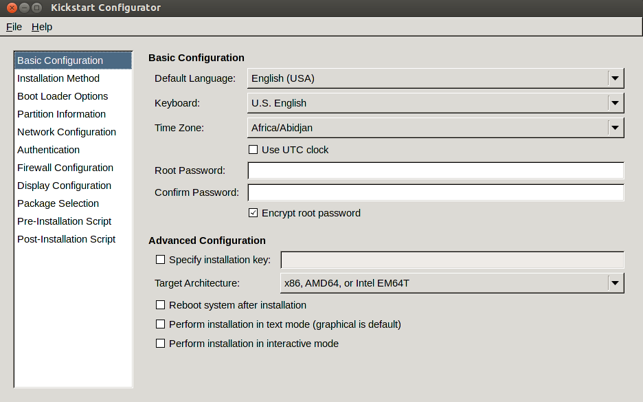

创建PXE菜单密码
# openssl passwd -1 -salt medees 123456
$1$medees$IW4PpkV0IyAHEwodE8R8y.
# vim /etc/cobbler/pxe/pxedefault.template
MENU TITLE Cobbler | http://www.cobblerd.org/
MENU MASTER PASSWD $1$medees$IW4PpkV0IyAHEwodE8R8y.
TIMEOUT 200
# vim /etc/cobbler/pxe/pxeprofile.template
LABEL $profile_name
MENU PASSWD
kernel $kernel_path
$menu_label
$append_line
ipappend 2

启动xinetd服务
# /etc/init.d/xinetd start

同步cobbler配置
# cobbler sync
若报错:
Exception value: 'ascii' codec can't decode byte 0xc2 in position 59: ordinal not in range(128)
解决办法：
# vim /usr/lib64/python2.6/site-packages/sitecustomize.py
#encoding=GBK
import sys
reload(sys)
sys.setdefaultencoding('GBK')

使用虚拟机来测试cobbler安装
新建虚拟机，启动方式选择network
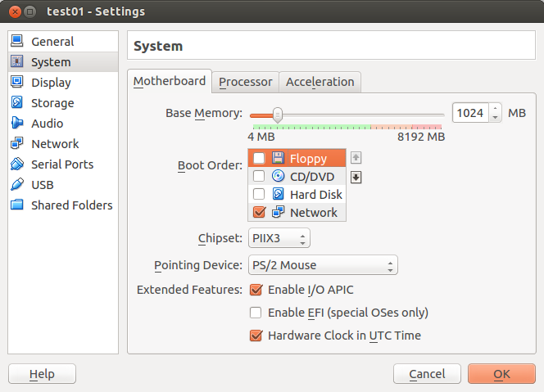
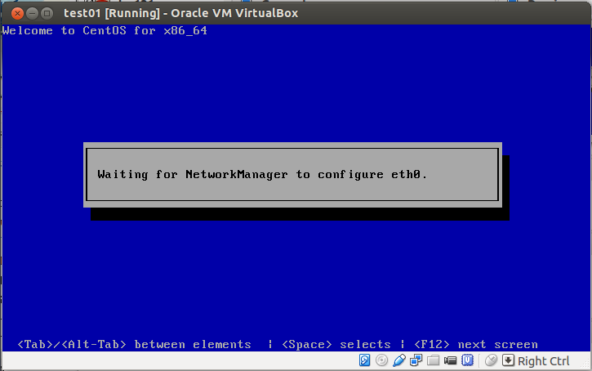

命令行管理cobbler,进行ubuntu系统安装

导入安装文件
# cobbler import --path=/mnt --name=ubuntu-12.04 --arch=x86_64
一般网络安装会选择alternate版本(利用cobbler进行安装文件导入一般不会报错)，它是由许多deb包组成的。可以详细的制定安装内容，因此alternate安装与desktop安装相比之下会慢一些.

若导入报错（非alternate版本导入时一般都会报此错误）
# cobbler import --path=/mnt --name=ubuntu-14.04 --arch=x86_64
task started: 2014-08-05_164456_import
task started (id=Media import, time=Tue Aug 5 16:44:56 2014)
No signature matched in /var/www/cobbler/ks_mirror/ubuntukylin-14.04-desktop-amd64-x86_64
!!! TASK FAILED !!!
忽略上面的错误,执行5.4加入 distro 和 profile.

新建安装配置文件
# vim /var/lib/cobbler/kickstarts/sample.seed
- d-i debian-installer/locale string en_US
- d-i debian-installer/language string en
- d-i debian-installer/country string US
- d-i console-setup/ask_detect boolean false

- d-i keyboard-configuration/layoutcode string us
- d-i localechooser/supported-locales zh_CN.UTF-8
- d-i netcfg/enable boolean false

- d-i netcfg/choose_interface select auto
- d-i netcfg/disable_autoconfig boolean true
- d-i netcfg/dhcp_failed note
- d-i netcfg/dhcp_options select Do not configure the network at this time

- #d-i mirror/country string manual
- #d-i mirror/http/countries select enter information manually
- #d-i mirror/http/hostname string cn.archive.ubuntu.com
- #d-i mirror/http/directory string /ubuntu
- #d-i mirror/http/mirror select cn.archive.ubuntu.com
- #d-i mirror/http/proxy string
- #d-i mirror/suite string precise
- #d-i mirror/protocol select http
- #d-i mirror/udeb/components multiselect main, restricted

- # Setup the installation source
- d-i mirror/country string manual
- d-i mirror/http/hostname string $http_server
- d-i mirror/http/directory string $install_source_directory
- d-i mirror/http/proxy string

- d-i clock-setup/utc boolean true
- d-i clock-setup/ntp boolean true
- d-i clock-setup/ntp-server string 10.90.5.133
- d-i time/zone string Asia/Shanghai

- d-i partman-auto/disk string /dev/sda
- d-i partman-auto/method string regular
- d-i partman-lvm/device_remove_lvm boolean true
- d-i partman-md/device_remove_md boolean true
- d-i partman-lvm/confirm boolean true
- d-i partman-auto/expert_recipe string \
- boot-root :: \
- 200 50 200 ext4 \
- $primary{ } $bootable{ } \
- method{ format } format{ } \
- use_filesystem{ } filesystem{ ext4 } \
- mountpoint{ /boot } \
- . \
- 500 10000 100000000000 ext4 \
- method{ format } format{ } \
- use_filesystem{ } filesystem{ ext4 } \
- mountpoint{ / } \
- . \
- 2048 512 2048 linux-swap \
- method{ swap } format{ } \
- .
- d-i partman/default_filesystem string ext4
- d-i partman-partitioning/confirm_write_new_label boolean true
- d-i partman/choose_partition select finish
- d-i partman/confirm boolean true
- d-i partman/confirm_nooverwrite boolean true
- d-i partman/mount_style select uuid
- d-i passwd/root-login boolean false
- d-i passwd/root-password password 123456
- d-i passwd/root-password-again password 123456
- d-i user-setup/allow-password-weak boolean true
- d-i user-setup/encrypt-home boolean false
- d-i passwd/make-user boolean false
- d-i passwd/make-user boolean true
- d-i passwd/user-fullname string medees
- d-i passwd/username string medees
- d-i passwd/user-password password 123456
- d-i passwd/user-password-again password 123456
- #d-i passwd/make-user boolean true
- #d-i passwd/user-fullname string yx
- #d-i passwd/username string yx
- #d-i passwd/user-password-crypted password 123456
- #d-i user-setup/allow-password-weak boolean true
- #d-i user-setup/encrypt-home boolean false

- tasksel tasksel/first multiselect standard
- d-i pkgsel/include string openssh-server
- d-i pkgsel/include string ubuntu-desktop
- d-i pkgsel/upgrade select none
- d-i pkgsel/install-language-support boolean true
- d-i pkgsel/language-packs multiselect de, en, zh
- d-i pkgsel/update-policy select none
- d-i pkgsel/updatedb boolean false
- d-i grub-installer/only_debian boolean true
- d-i grub-installer/with_other_os boolean true
- d-i finish-install/reboot_in_progress note

修改安装配置文件
# cobbler profile edit --name=ubuntu-12.04-x86_64 --kickstart=/var/lib/cobbler/kickstarts/sample.seed

加入 distro 和 profile
# cd /var/www/cobbler/links/
# ln -s /var/www/cobbler/ks_mirror/ubuntukylin-14.04-desktop-amd64-x86_64 ubuntukylin-14.04-desktop-amd64-x86_64
# cobbler distro add --name=ubuntukylin-14.04-desktop-amd64-x86_64 --kernel=/var/www/cobbler/ks_mirror/ubuntukylin-14.04-desktop-amd64-x86_64/install/ubuntu-installer/amd64/linux --initrd=/var/www/cobbler/ks_mirror/ubuntukylin-14.04-desktop-amd64-x86_64/install/ubuntu-installer/amd64/initrd.gz --arch=x86_64 --breed=ubuntu --ksmeta="directory=/cblr/links/ubuntukylin-14.04-desktop-amd64-x86_64"
# cobbler profile add --name=ubuntukylin-14.04-desktop-amd64-x86_64 --distro=ubuntukylin-14.04-desktop-amd64-x86_64 --kickstart=/var/lib/cobbler/kickstarts/sample.seedd

查看导入列表
# cobbler list
distros:
CentOS-6.1-x86_64
ubuntukylin-14.04-desktop-amd64-x86_64

profiles:
CentOS-6.1-x86_64
ubuntukylin-14.04-desktop-amd64-x86_64

systems:

repos:

images:

mgmtclasses:

packages:

files:

重启动服务
# /etc/init.d/cobblerd restart
Stopping cobbler daemon: [ OK ]
Starting cobbler daemon: [ OK ]
# /etc/init.d/xinetd restart
Stopping xinetd: [ OK ]
Starting xinetd: [ OK ]

使用虚拟机来测试cobbler安装

Cobbler相关文件和相关操作说明

Cobbler配置文件
Cobbler配置文件存放在/etc/cobbler下
配置文件名称 | 作 用
/etc/cobbler/settings | Cobbler主配置文件
/etc/cobbler/users.digest | 用于web访问的用户名密码配置文件
/etc/cobbler/modules.conf | 模块配置文件
/etc/cobbler/users.conf | Cobbler WebUI/Web 服务授权配置文件
/etc/cobbler/iso/ | Buildiso 模板配置文件
/etc/cobbler/power | 电源配置文件
/etc/cobbler/pxe | Pxeprofile配置模板
/etc/cobbler | 此目录也包含rsync、dhcp、dns、pxe、dnsmasq等服务的模板配置文件

系统镜像数据目录
repos镜像和kickstart文件都放置在/var/www/cobbler目录下。确保/var目录有足够的空间来存储这些文件。
目录名称 | 作 用
/var/www/cobbler/images/ | 存储所有导入发行版的Kernel和initrd镜像用于远程网络启动
/var/www/cobbler/ks_mirror/ | 存储导入的发行版系统数据
/var/www/cobbler/repo_mirror/ | 仓库存储目录
/var/log/cobbler | Cobbler日志文件 cobbler.log install.log

Cobbler数据目录
/var/lib/cobbler目录存储和Cobbler profiles、systems、distros相关的配置。
目录名称 | 作 用
/var/lib/cobbler/config/ | 存放distros、repos、systems和profiles等信息配置文件，一般都是json文件
/var/lib/cobbler/snippets/ | 存放ks文件可以导入的脚本小片段，值得研究
/var/lib/cobbler/triggers | 存放用户定义的cobbler 命令
/var/lib/cobbler/kickstarts/ | 存放kickstart配置文件

相关日志文件

web日志存放点
/var/log/httpd/access_log
/var/log/httpd/error_log
/var/log/httpd/ssl_access_log
/var/log/httpd/ssl_error_log

Cobbler日志
/var/log/cobbler/cobbler.log
/var/log/cobbler/install.log
通过Cobbler日志可以获取系统的安装状态

删除导入的系统
cobbler profile find --distro=centos6.4-x86_64 #查看配置是否存在
centos6.4-x86_64
cobbler profile remove --name=centos6.4-x64-x86_64 #删除配置文件
cobbler distro remove --name=centos6.4-x86_64 #删除distro
cobbler profile find --distro=centos6.4-x86_64 #再查看配置已无

Cobbler_web进行系统安装管理

配置Cobbler_web

安装依赖组件Django和mod_ssl
# yum install -y Django
# yum install -y mod_ssl

安装cobbler-web
# yum -y install cobbler-web

重启httpd以让ssl服务生效
# /etc/init.d/httpd restart

为Cobbler用户修改密码
# htdigest /etc/cobbler/users.digest "Cobbler" cobbler

为Cobbler Web增加新用户
# htdigest /etc/cobbler/users.digest "Cobbler" yx

修改配置文件
# vim /etc/cobbler/modules.conf
[authentication]
module = authn_configfile

重启Cobbler服务
# /etc/init.d/cobblerd restart
# /etc/init.d/httpd restart
# /etc/init.d/xinetd restart
浏览器中输入http：//cobbler服务器IP/cobbler_web,利用上面创建的用户名和密码登录

利用web进行cobble系统安装配置（基本操作）

登录界面
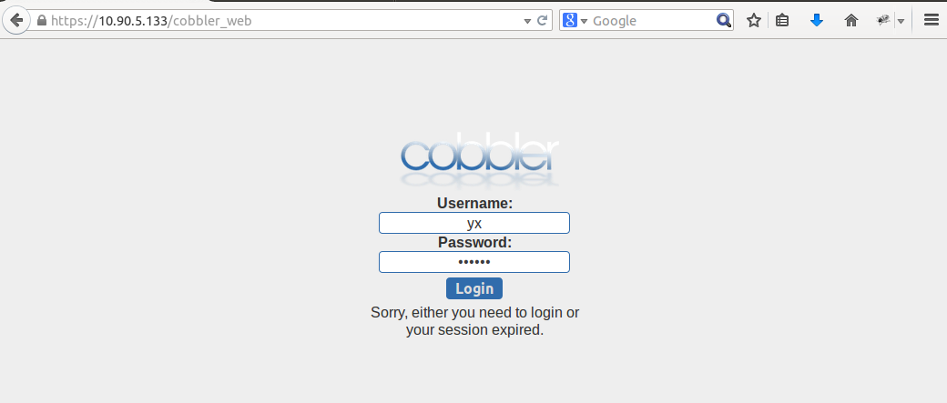

管理界面
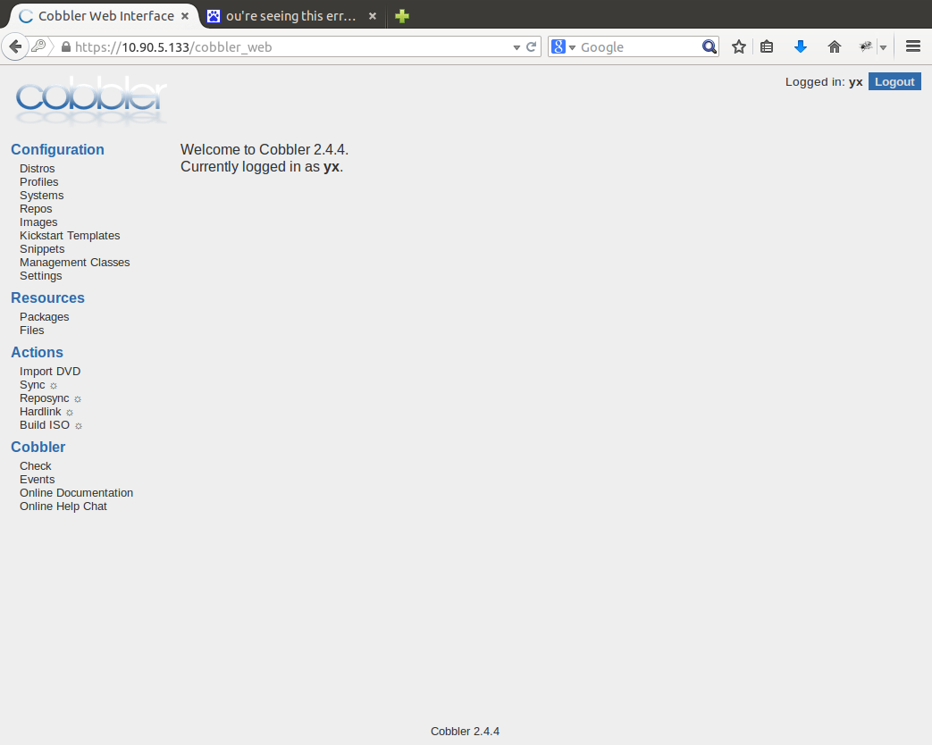

通过web导入光盘镜像
import DVD
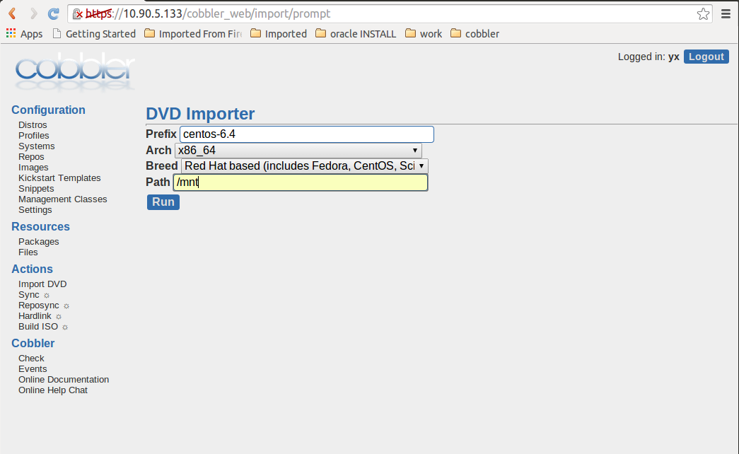
在prefix项中要填写导入光盘的名字，只有不与先前的名字冲突，这里可以随意填。 在Arch项中选择光盘的类型，是i386、x86_64、ai64等。 在Breed项中选择系统的类型，CentOS、Debian、Ubuntu中的一种。 在Path项中填写光盘或ISO镜像包挂载的位置。 完成后点Run，界面：
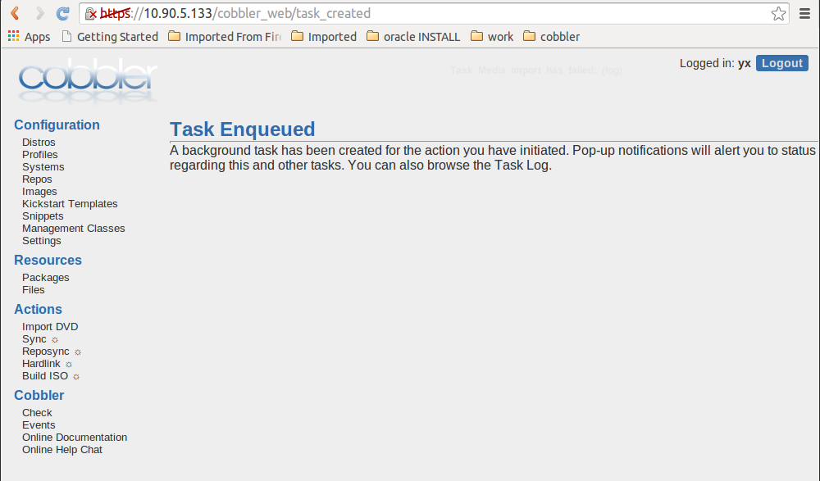

查看导入日志
光盘导入比较慢，等适当的一段时间后，点Events查看日志,在该界面可以查看log

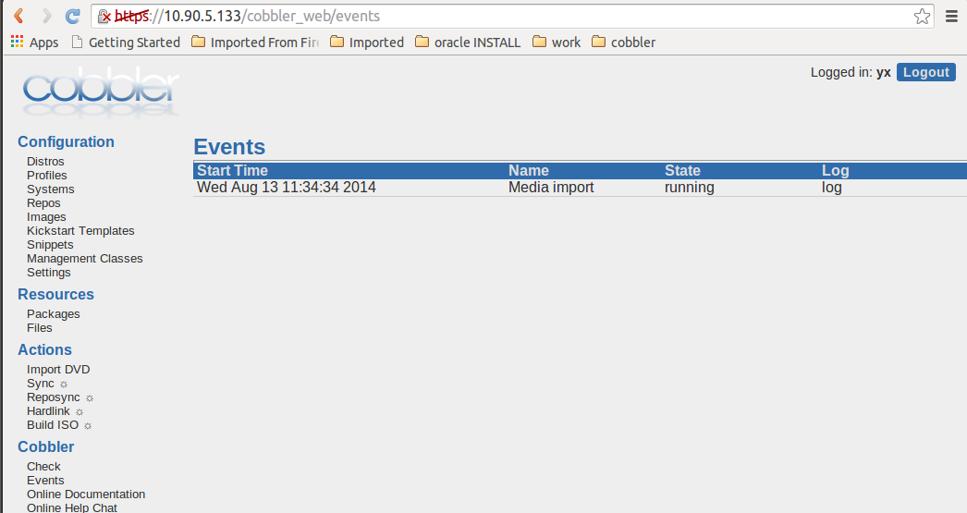

出现complete即为导入完成
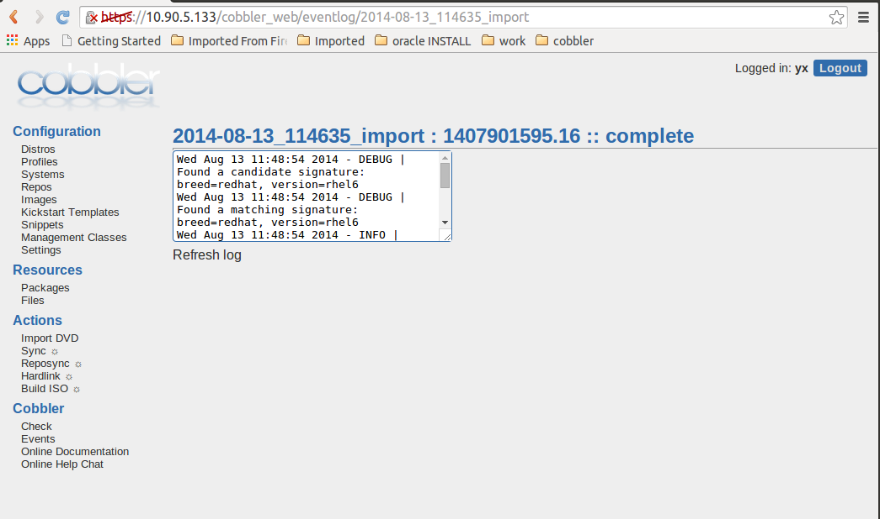

查看distro
点 Distros菜单,可以对各个欲安装系统进行编辑删除等操作
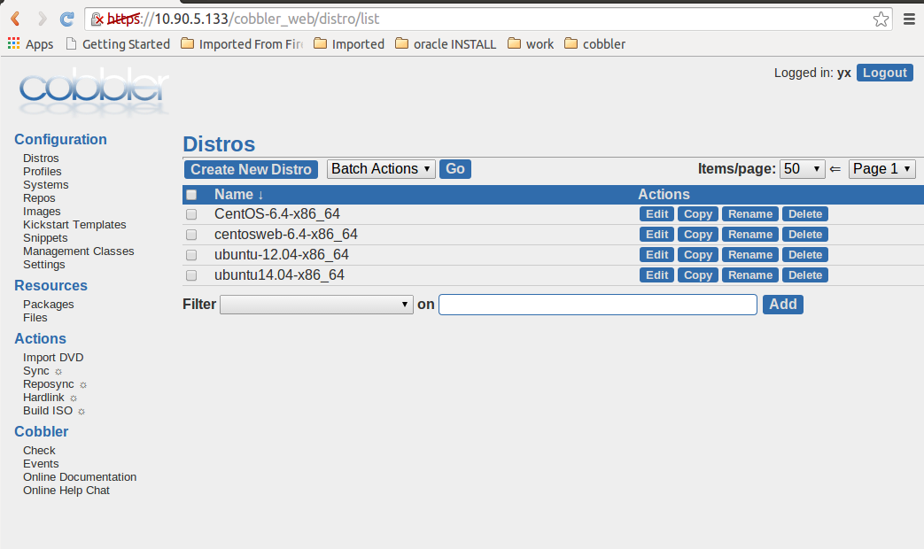

查看profiles
点Profiles菜单
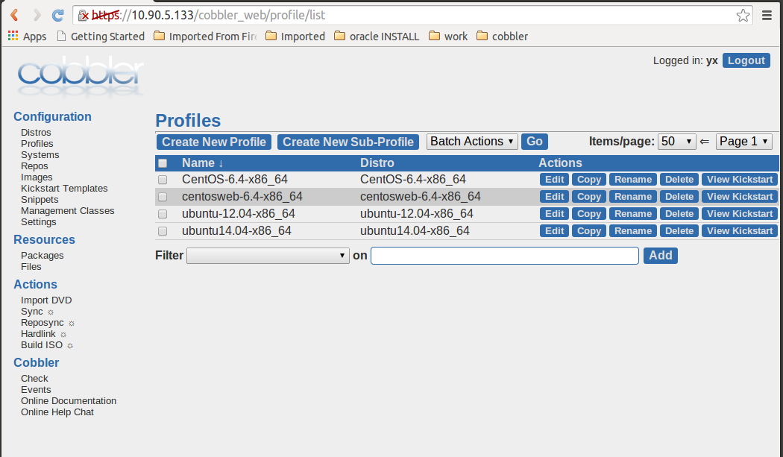

设置系统安装配置文件
点 Kickstart Tempates菜单
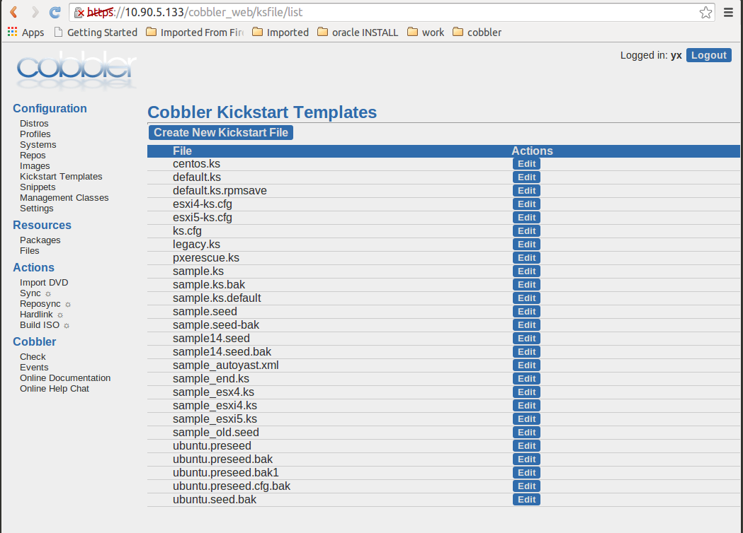
可以编辑、新建、删除kickstart文件

